Name: Abhishek Patil Class: CSAIML-A PRN: 12414243 Roll No.: 08

ASSIGNMENT: 5

- Program to print hollow rectangle or square star patterns.
********************
* *
* *
* *
********************
Algorithm:
- Start
- Input the number of rows and columns
- Use a loop from i = 1 to rows (outer loop for rows):
- For each row, use a nested loop from j = 1 to columns (inner loop for columns):
  - If i == 1 or i == rows or j == 1 or j == columns, print *
  - Else, print a space ' '
- After the inner loop ends, move to the next line (\n)
- End

Code:
#include <stdio.h>

int main() {
int rows, cols;
printf("Enter number of rows and columns: ");
scanf("%d %d", &rows, &cols);

for(int i = 1; i <= rows; i++) {
for(int j = 1; j <= cols; j++) {
if(i == 1 || i == rows || j == 1 || j == cols)
printf("*");
else
printf(" ");
}
printf("\n");
}
return 0;
}

Flowchart:

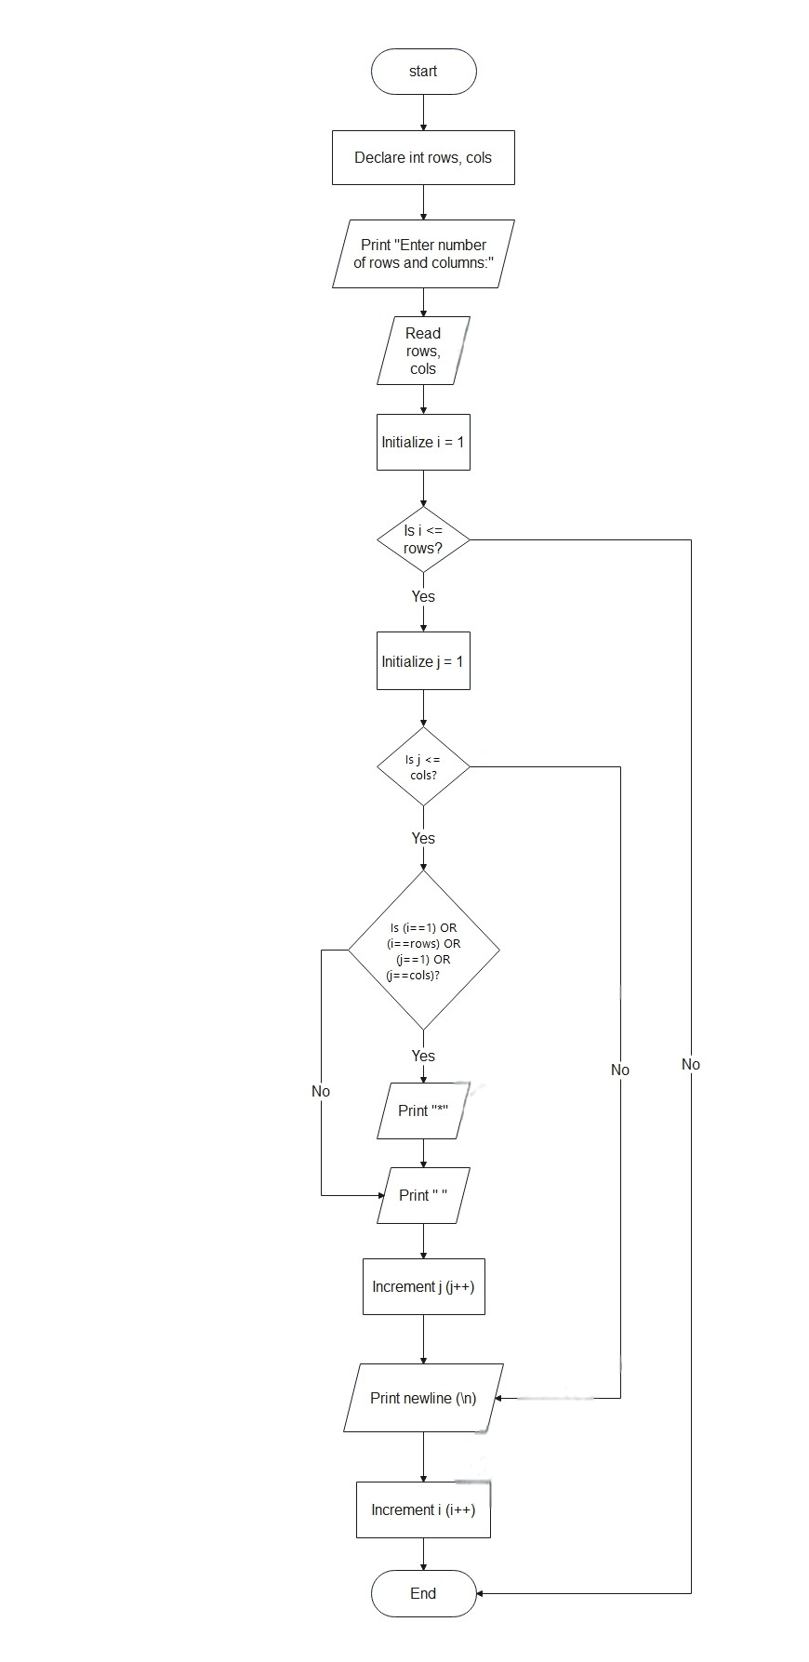
- Write a C program to print pascal triangle up to n rows using loop
Algorithm:
- Start
- Input the number of rows for the triangle
- Use a loop from i = 0 to rows-1 (row by row):
- Print spaces to center-align the triangle
- Initialize coef = 1 at the start of each row
- Use a nested loop from j = 0 to i:
  - Calculate value using formula: coef = coef * (i - j + 1) / j (except for j=0 where coef = 1)
  - Print the coefficient
- Move to the next line after each row
- End

Code:
#include <stdio.h>

int main() {
int rows, coef = 1, space, i, j;
printf("Enter the number of rows: ");
scanf("%d", &rows);

for(i = 0; i < rows; i++) {
for(space = 1; space <= rows - i; space++)
printf(" ");

for(j = 0; j <= i; j++) {
if (j == 0 || i == 0)
coef = 1;
else
coef = coef * (i - j + 1) / j;
printf("%4d", coef);
}
printf("\n");
}
return 0;
}

Flowchart:

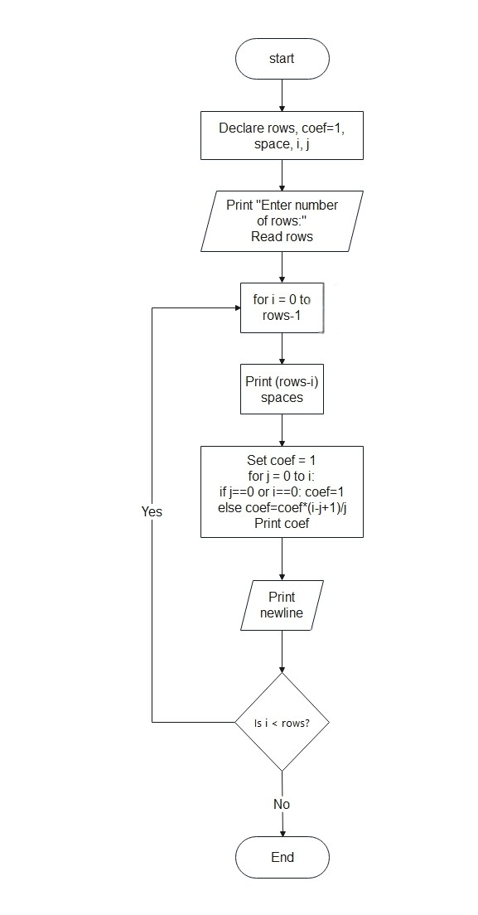
- Write a c program to display Floyd’s Triangle. Floyd’s Triangle is a right-angled triangular array of natural numbers. It starts with 1 at the top left and increases sequentially row by row.
Algorithm:
- Start
- Input the number of rows
- Initialize a variable num = 1
- Use a loop from i = 1 to rows (for each row):
- Inside it, run another loop from j = 1 to i:
  - Print the current number num
  - Increment num by 1
- After the inner loop ends, move to the next line
- End

Code:
#include <stdio.h>

int main() {
int rows, num = 1, i, j;
printf("Enter the number of rows: ");
scanf("%d", &rows);

for(i = 1; i <= rows; i++) {
for(j = 1; j <= i; j++) {
printf("%d ", num);
num++;
}
printf("\n");
}
return 0;
}

Flowchart:
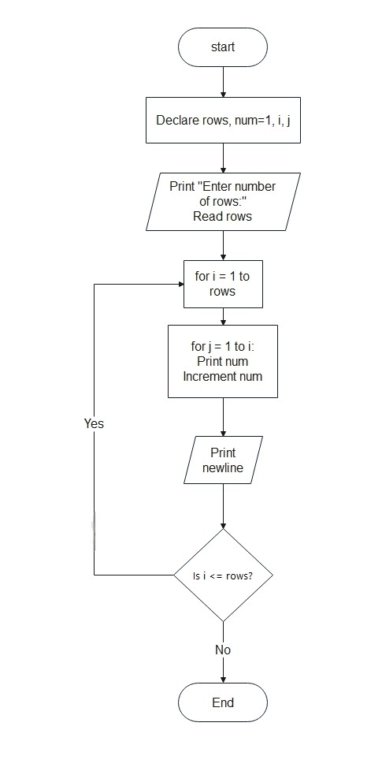
- Write a c program to display diamond star pattern
Algorithm:
- Start
- Input the number n (half the height of the diamond)
- Upper half of the diamond:
  - Loop from i = 1 to n:
    - Print (n - i) spaces
    - Print (2 * i - 1) stars
- Lower half of the diamond:
  - Loop from i = n-1 down to 1:
    - Print (n - i) spaces
    - Print (2 * i - 1) stars
- End

Code:
#include <stdio.h>

int main() {
int i, j, space, n;
printf("Enter the number of rows (half of diamond height): ");
scanf("%d", &n);

// Upper half
for(i = 1; i <= n; i++) {
for(space = 1; space <= n - i; space++)
printf(" ");
for(j = 1; j <= 2 * i - 1; j++)
printf("*");
printf("\n");
}

// Lower half
for(i = n-1; i >= 1; i--) {
for(space = 1; space <= n - i; space++)
printf(" ");
for(j = 1; j <= 2 * i - 1; j++)
printf("*");
printf("\n");
}

return 0;
}

Flowchart:
